TERRAFORM - CHALLENGES
=============================================

Write a code using Terraform that deploys and achieves the following:-
Create an EC2 Instance on AWS Cloud using the below-mentioned ubuntu AMI and instance_type. Or, (You can use of your choice as well) ami = "ami-0461b1436c9b3c1a3" instance_type = "t2.micro"
Install a web server on the same EC2 Instance. The web server should listen on port 8080.
- Create a Docker-compose file for the project: https://github.com/betawins/cricbuzz-docker-hello-world.git and point it to port 8000.
- Make the web server point to the above service so that 8080 returns the response from the Docker service.
- Configure to Save the Logs in the location /var/log/cb.log
- Write the Log rotate configuration for the above file

provider "aws" {
region = "eu-north-1"
}

# -------------------------
# Key Pair (uses your local public key)
# -------------------------
resource "aws_key_pair" "cb_key" {
key_name = "cb-key"
public_key = file("~/.ssh/id_rsa.pub")
}

# -------------------------
# Security Group (Allow SSH + 8080 + 8000)
# -------------------------
resource "aws_security_group" "cb_sg" {
name = "cb-sg"
description = "Allow SSH and app ports"

ingress {
description = "SSH"
from_port = 22
to_port = 22
protocol = "tcp"
cidr_blocks = ["0.0.0.0/0"]
}

ingress {
description = "Nginx Reverse Proxy Port"
from_port = 8080
to_port = 8080
protocol = "tcp"
cidr_blocks = ["0.0.0.0/0"]
}

ingress {
description = "Docker App Port"
from_port = 8000
to_port = 8000
protocol = "tcp"
cidr_blocks = ["0.0.0.0/0"]
}

egress {
description = "Allow all outbound"
from_port = 0
to_port = 0
protocol = "-1"
cidr_blocks = ["0.0.0.0/0"]
}
}

# -------------------------
# EC2 Instance
# -------------------------
resource "aws_instance" "cb_ec2" {
ami = "ami-073130f74f5ffb161"
instance_type = "t3.small"
key_name = aws_key_pair.cb_key.key_name
vpc_security_group_ids = [aws_security_group.cb_sg.id]

user_data = <<-EOF
#!/bin/bash
set -e

apt-get update -y

# Install packages
apt-get install -y docker.io docker-compose nginx git logrotate

systemctl enable docker
systemctl start docker

systemctl enable nginx
systemctl start nginx

# Clone project
cd /opt
rm -rf cricbuzz-docker-hello-world || true
git clone https://github.com/betawins/cricbuzz-docker-hello-world.git
cd cricbuzz-docker-hello-world

# Create docker-compose file (App runs on 8000)
cat > docker-compose.yml <<EOL
version: "3.8"
services:
cb-app:
image: nginx:alpine
container_name: cb-app
ports:
- "8000:80"
restart: always
EOL

# Start docker container
docker-compose up -d

# Nginx reverse proxy config (8080 -> 8000)
rm -f /etc/nginx/sites-enabled/default

cat > /etc/nginx/sites-available/cb-proxy <<EOL
server {
listen 8080;

access_log /var/log/cb.log;
error_log /var/log/cb.log;

location / {
proxy_pass http://127.0.0.1:8000;
proxy_set_header Host \$host;
proxy_set_header X-Real-IP \$remote_addr;
proxy_set_header X-Forwarded-For \$proxy_add_x_forwarded_for;
}
}
EOL

ln -s /etc/nginx/sites-available/cb-proxy /etc/nginx/sites-enabled/cb-proxy

systemctl restart nginx

# Logrotate config for /var/log/cb.log
cat > /etc/logrotate.d/cb-log <<EOL
/var/log/cb.log {
daily
rotate 7
compress
missingok
notifempty
create 0644 root root
sharedscripts
postrotate
systemctl reload nginx > /dev/null 2>/dev/null || true
endscript
}
EOL
EOF

tags = {
Name = "cb-ec2"
}
}

output "ec2_public_ip" {
value = aws_instance.cb_ec2.public_ip
}

Open VS Code and go to main.tf
- Configure AWS provider:
- Set region to eu-north-1
- Create Key Pair using your local public key:
- Resource: aws_key_pair
- Key path: ~/.ssh/id_rsa.pub
- Create a Security Group named cb-sg
- Add Ingress rules:
- SSH 22
- Nginx Reverse Proxy Port 8080
- Docker App Port 8000
- Allow traffic from:
- 0.0.0.0/0
- 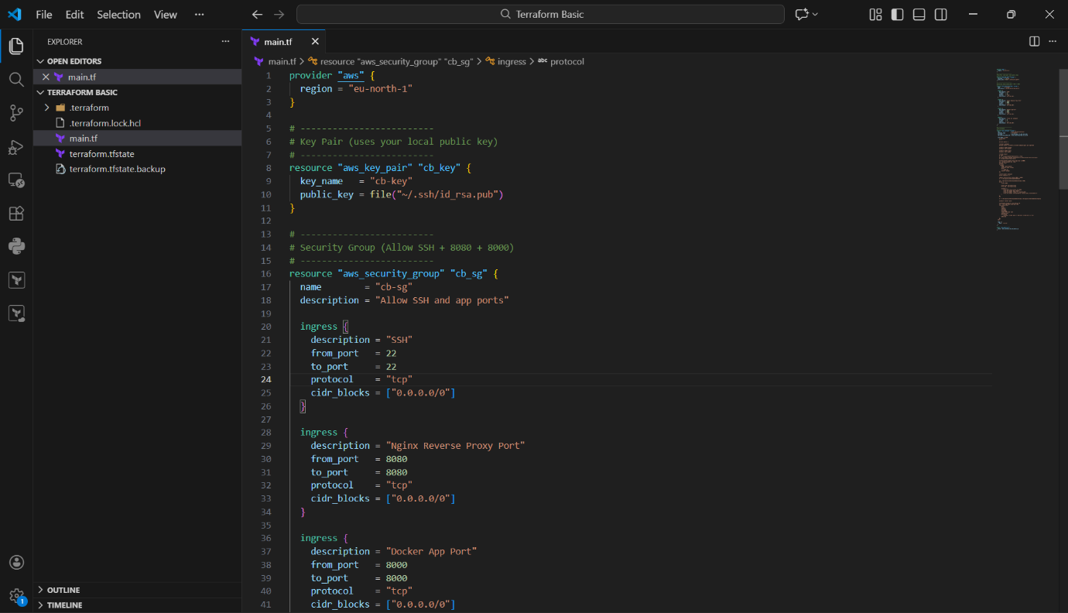
- ontinue inside aws_security_group resource
- Add Egress rule:
- Allow all outbound traffic (protocol = "-1")
- CIDR: 0.0.0.0/0
- Start creating the EC2 instance resource:
- Resource: aws_instance "cb_ec2"
- Define values:
- AMI ID
- Instance type (shown: t3.small)
- Attach key pair: aws_key_pair.cb_key.key_name
- Attach security group: aws_security_group.cb_sg.id

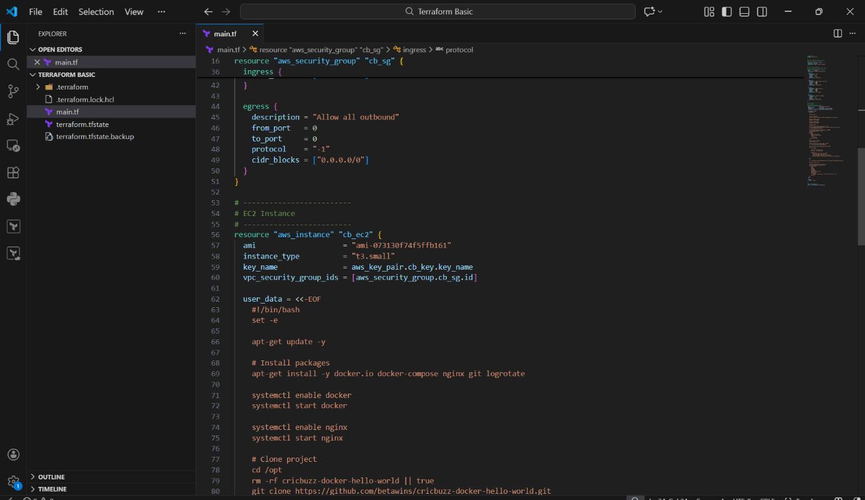

- Add user_data script inside EC2 resource
- Script performs:
  - Install required packages:
    - docker, docker-compose, nginx, git, logrotate
- Clone GitHub project:
  - https://github.com/betawins/cricbuzz-docker-hello-world.git
- Go inside project folder
- Create docker-compose.yml file with:
  - Service using nginx:alpine
  - Port mapping:
    - 8000:80
- Start container:
  - docker-compose up -d
- Configure Nginx reverse proxy:
  - Listen on 8080
  - Proxy pass to 127.0.0.1:8000
- Restart nginx:
  - systemctl restart nginx
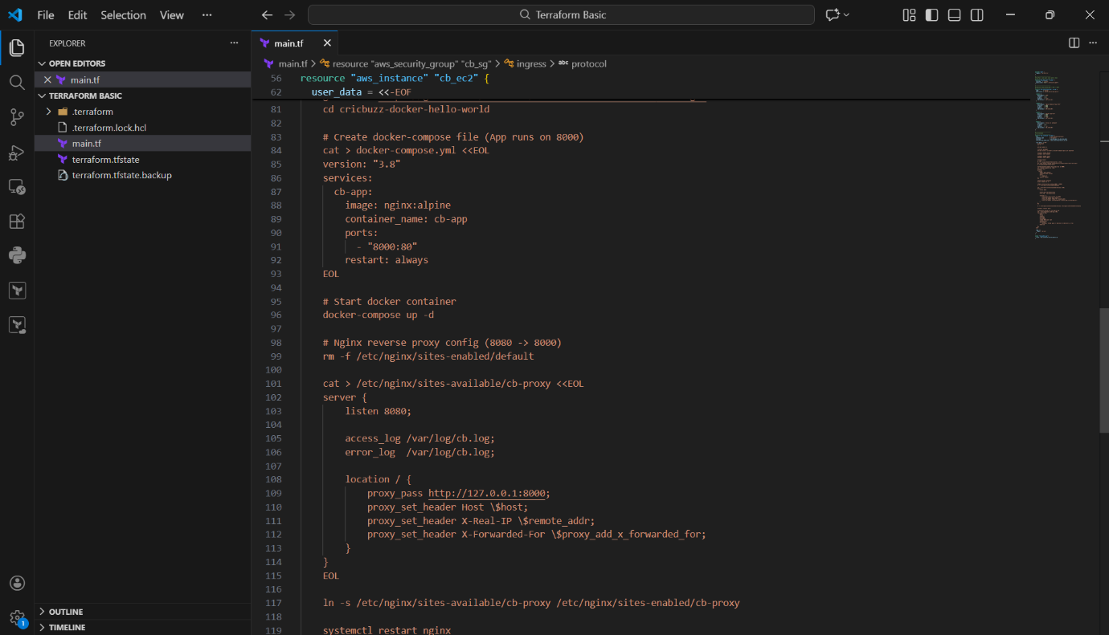

- In user_data, create Logrotate config file:
- Path: /etc/logrotate.d/cb-log
- Configure log rotation for:
- /var/log/cb.log
- Settings included:
- daily rotate
- keep 7 files
- compress
- create permissions
- reload nginx after rotate
- Add EC2 tagging:
- Name = cb-ec2
- Add output block:
- Output EC2 public IP
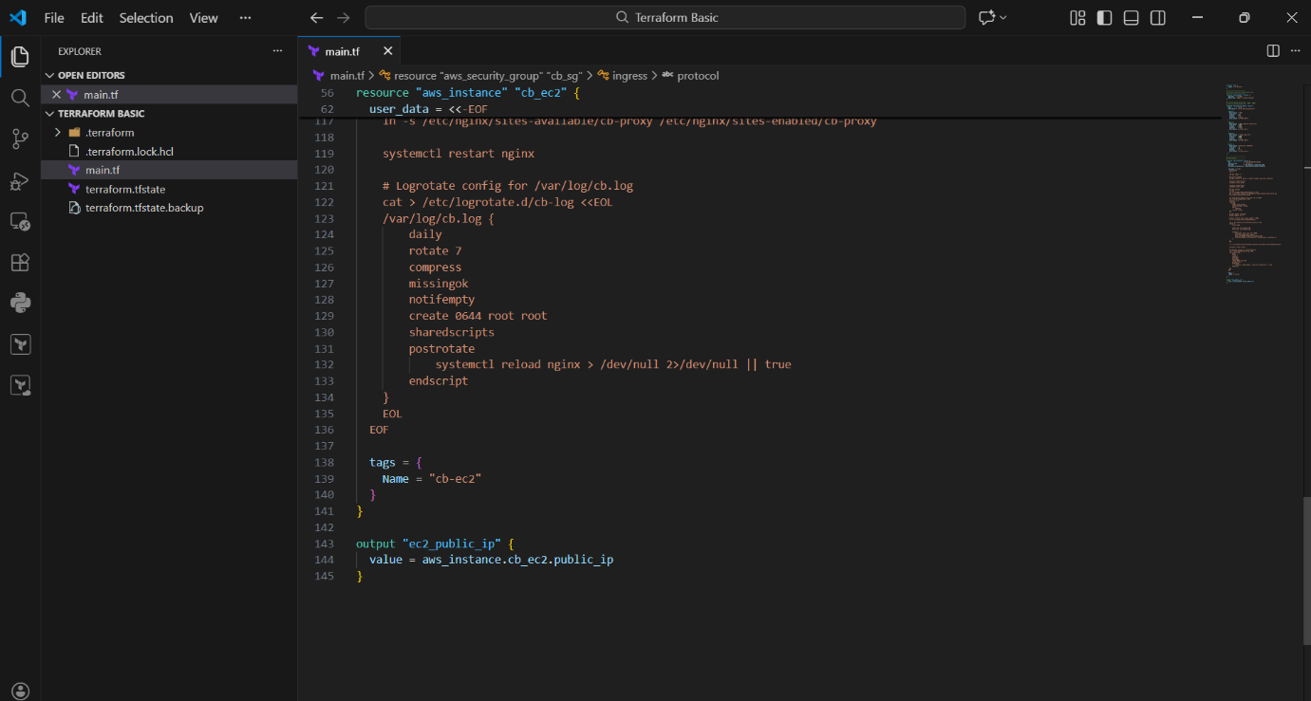

- Open VS Code Terminal (PowerShell)
- Run Terraform initialization:
- terraform init
- Verify output:
- Provider plugins downloaded
- Terraform initialized successfully
- Run apply command:
- terraform apply -auto-approve
- Terraform creates resources:
- Security group
- Key pair
- EC2 instance
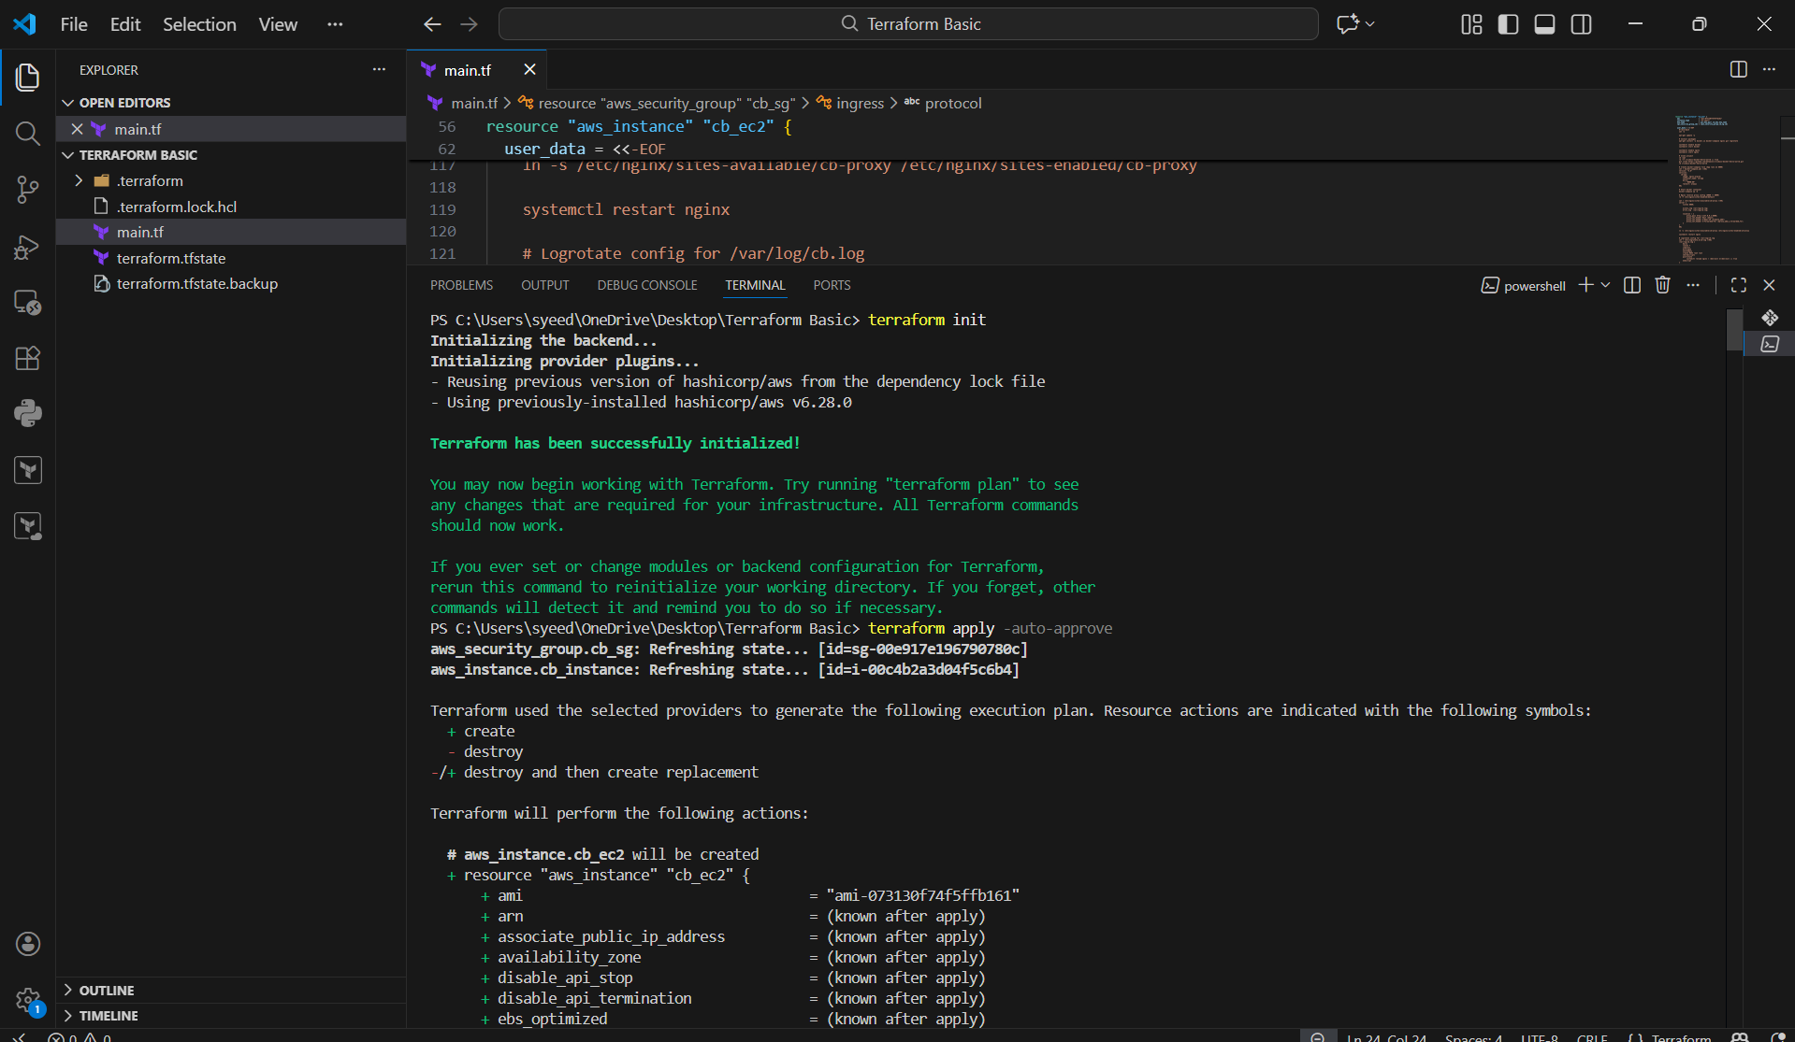
- Wait until EC2 creation finishes
- Confirm success message:
- “Apply complete!”
- Terraform prints output:
- Public IP shown (example from image):
- ec2_public_ip = "51.20.93.220"
- Use the IP to test your app:
- Open browser:
- http://51.20.93.220:8080
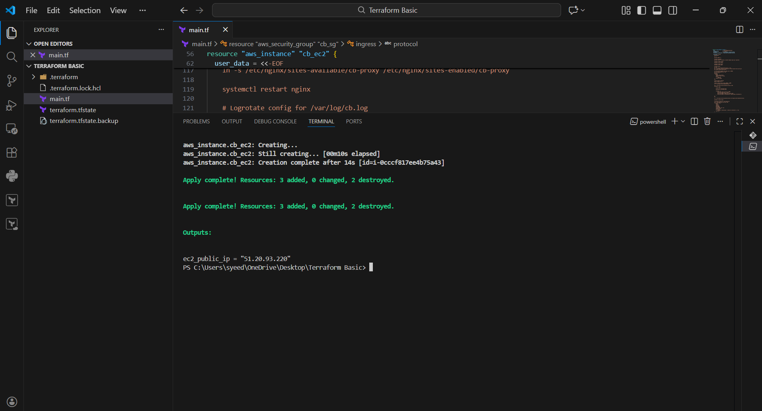

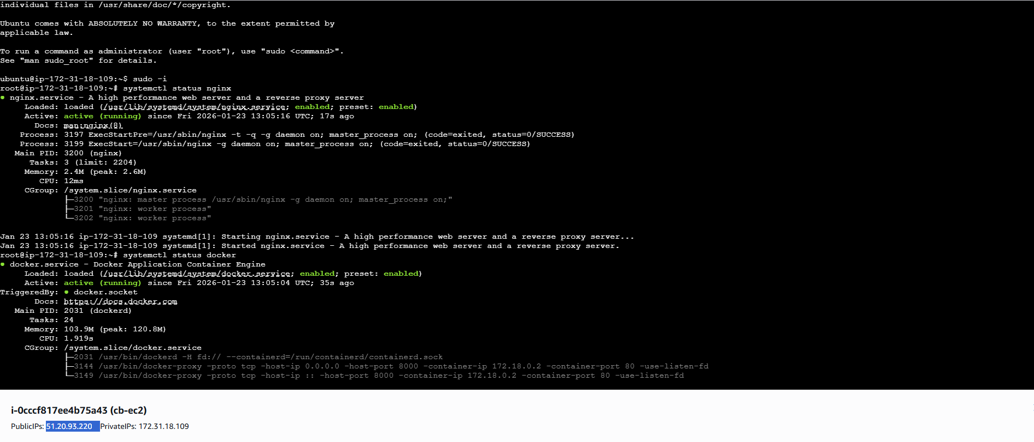

- Open browser
- Enter EC2 public IP with port 8080:
- http://51.20.93.220:8080
- If you see Welcome to nginx!
It confirms Nginx is working on port 8080
Steps:
- Open browser
- Enter EC2 public IP with port 8000:
- http://51.20.93.220:8000
- If you see Welcome to nginx!
It confirms Docker container service is running on port 8000

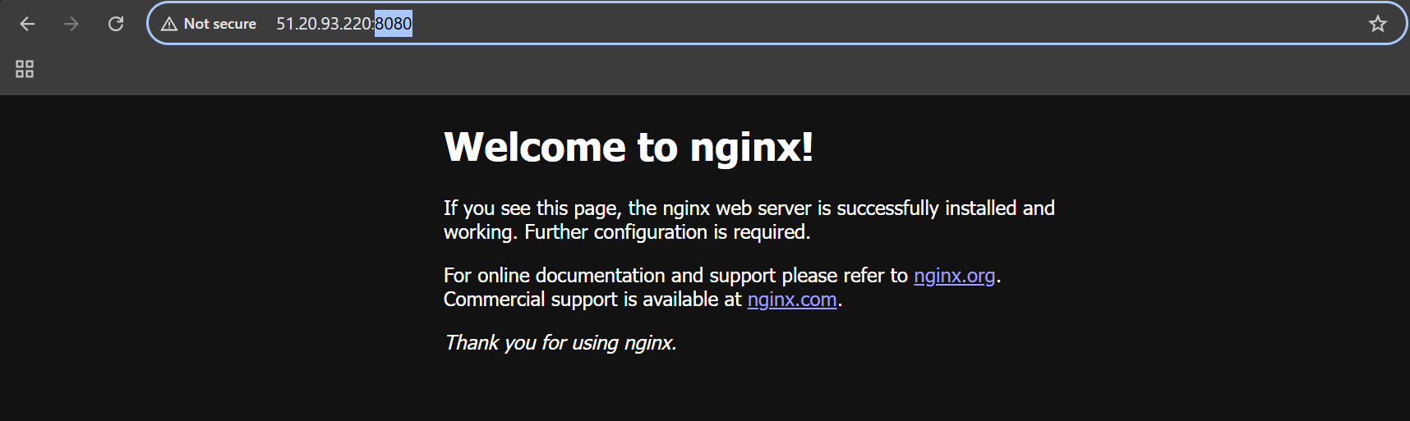

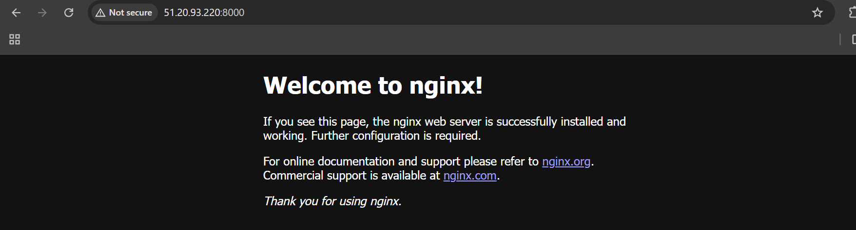

Check Logs Saved in /var/log/cb.log
Steps:
- Login to EC2 using SSH
- Switch to root user:
- sudo -i
- View the log file:
- cat /var/log/cb.log
- Confirm the logs are getting written (example from image):
  - GET / HTTP/1.1 200
  - GET /favicon.ico 404
This verifies Nginx access logs are successfully stored in /var/log/cb.log

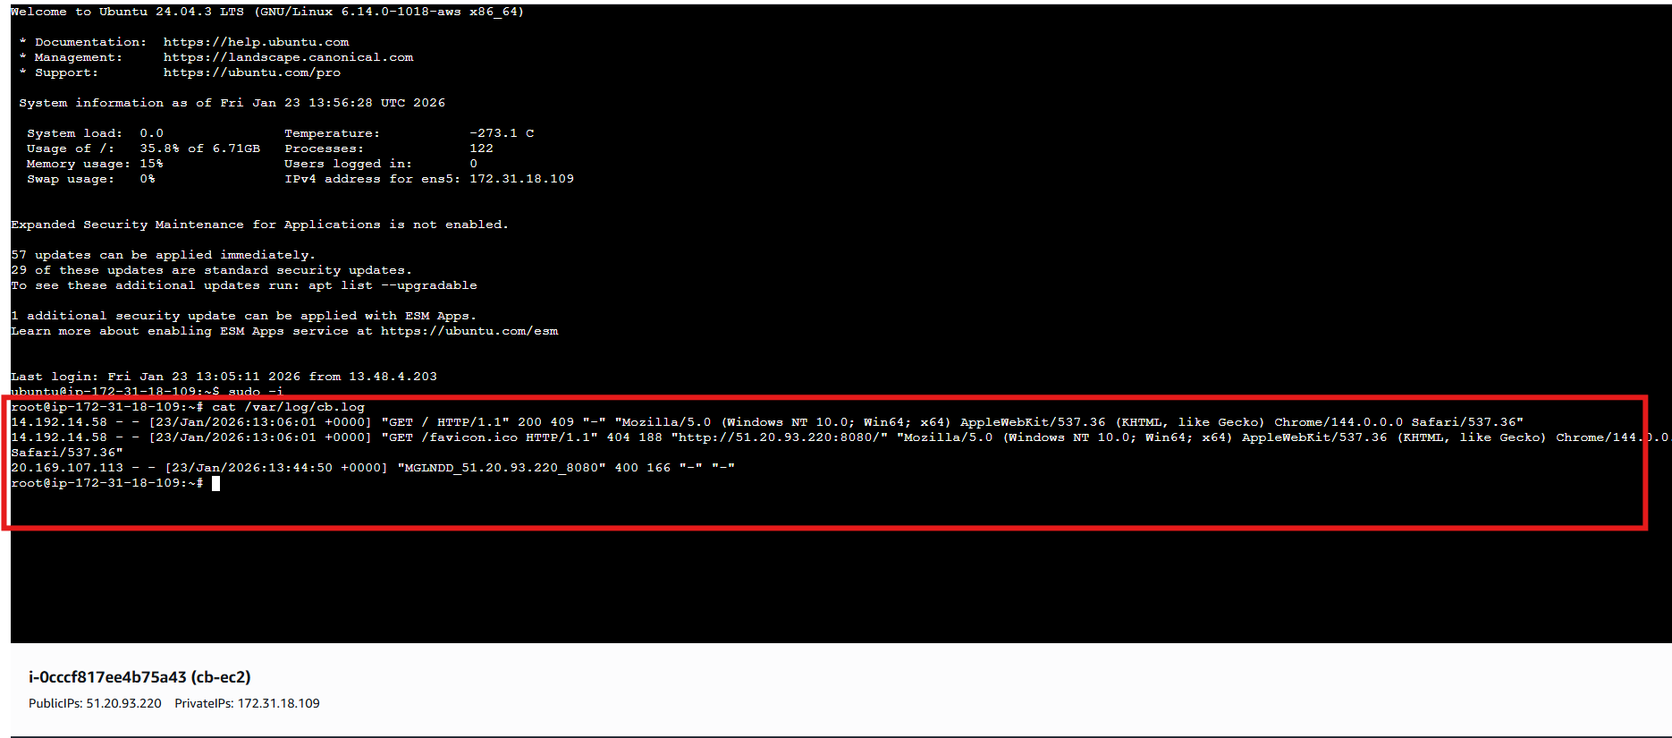

Steps:
- Go to logrotate directory:
- cd /etc/logrotate.d/
- List all logrotate config files:
- ll
- Find and open your custom logrotate file (example: cb-log):
- cat cb-log
- Verify the configuration includes:
  - Log file path: /var/log/cb.log
  - Daily rotation:
  - daily
  - Keep 7 old logs:
  - rotate 7
  - Compress rotated logs:
  - compress
  - Skip error if missing:
  - missingok
  - Do not rotate if empty:
  - notifempty
  - Create new log file with permissions:
  - create 0644 root root
  - Reload nginx after rotation:
  - postrotate
  - systemctl reload nginx
  - endscript
This confirms log rotation is properly configured for /var/log/cb.log

